**TEST CASES**

**EXECUTION**

**RESULTS REPORT**

*Backbase Mobile Assignement*

*02-05-2020*

TABLE OF CONTENTS

1 Introduction 3

1.1 Purpose 3

2 OVERVIEW 3

2.1 *Test Type (Functional UI TESTING)* 3

3 Test Assessment 3

4 Test Results 3

4.1 *Sumary Results* 3

4.2 *Test cases details* 4

4.3 *Automation Report* 5

4.4 *Bugs details* 5

5 SuggEstIONs 5

# Introduction

## Purpose

This Backbase Mobile Assignement Test Report provides a summary of the results of test performed as outlined within this document.

# OVERVIEW

The native Android application was tested, this app shows a list of cities which you can search and when you choose a city the app shows a pin on a map. Then you can go back and repeat the process.

The executed test cases cover the following acceptance criteria:

* The cities are listed in ascending alphabetical order
* The cities list is scrollable
* The user of the application can search for specific city(ies)
* The user of the application can select a city to be displayed on the map
* The user of the application can interact with the map (i.e zoom in/out, move to the left/right)

During testing the first and the last acceptance criteria were not working as expected, the rest of the requirements were accomplished and some improvements were detected.

**Project Name**: *mobile-test*

**System Name**: *Mobile Assignment*

**Version Number**: *0.1*

## Test Type (Functional UI TESTING)

**Test Owner**: *Passalacqua Santiago*

**Test Date**: *[02/04/2020] - [02/05/2020]*

**Test Results**: *See section 4*

# Test Assessment

This test execution covers all UI Testing for the search feature, this feature was tested in only one device and non-functional testing was not performed. Define some KPA (Key performance indicator) would be useful to measure how the application is responding to the actions.

The TCs couldn’t be executed on Emulator devices because the available resources were not enough to have the application working properly, is recommendable to have some tool that allow us to execute this test in different devices.

# Test Results

## Sumary Results

The following results were obtained during testing:

|  |  |
| --- | --- |
| Number of test cases planned | 9 |
| Number of test cases executed | 9 |
| Number of test cases passed | 6 |
| Number of test cases failed | 3 |
| Number of test cases not planned | 0 |
| Number of test cases blocked | 0 |
| Number of test cases not executed | 0 |
| Number of defects encountered today | 4 |

## Test cases details

|  |  |  |  |  |  |  |
| --- | --- | --- | --- | --- | --- | --- |
| **TC ID** | **Scenarios** | **Execution Status** | **Is Automated** | **Defect ID** | **Severity** | **Status** |
| [TC_0001](Test%20Cases/TC_0001.docx) | Verify that the user is able to search a city in the list | Passed | Yes |  |  |  |
| [TC_0002](Test%20Cases/TC_0002.docx) | Verify results when the user search an unknown city in the list | Passed | Yes |  |  |  |
| [TC_0003](Test%20Cases/TC_0003.docx) | Verify that the cities are listed in ascending alphabetical order | Failed | No | DF_0001 | Med | Open |
| [TC_0004](Test%20Cases/TC_0004.docx) | Verify that the searched cities are listed in ascending alphabetical order | Failed | Yes | DF_0002 | Med | Open |
| [TC_0005](Test%20Cases/TC_0005.docx) | Verify that the user is able to scroll up and scroll down the list of cities | Passed | Yes |  |  |  |
| [TC_0006](Test%20Cases/TC_0006.docx) | Verify that the user is redirected to the map activity when a city is selected from the default list | Passed | Yes |  |  |  |
| [TC_0007](Test%20Cases/TC_0007.docx) | Verify that the user is redirected to the map activity when a searched city is selected | Passed | Yes |  |  |  |
| [TC_0008](Test%20Cases/TC_0008.docx) | Verify that the user is able to repeat the search process | Passed | Yes |  |  |  |
| [TC_0009](Test%20Cases/TC_0009.docx) | Verify that the user is able to interact with the map | Failed | No | DF_0004 | High | Open |

## Automation Report

[*Link to Automation Report*](Automation%20Execution%20Report/index.html)

## Bugs details

|  |  |  |  |  |
| --- | --- | --- | --- | --- |
| **ID** | **Title** | **% Occurrence** | **Severity** | **State** |
| [DF_0001](Bugs/DF_0001.docx) | The default list of cities is not ordered alphabetically | 100% | Med | Open |
| [DF_0002](Bugs/DF_0002.docx) | The filtered list of cities is not ordered alphabetically | 100% | Med | Open |
| [DF_0003](Bugs/DF_0003.docx) | The default list of cities is not fully displayed after the search field is deleted | 82% | Low | Open |
| [DF_0004](Bugs/DF_0004.docx) | The Map is not correctly displayed when a city is selected | 100% | High | Open |

# SuggEstIONs

1. Check if the filter in the list can be applied if the city contains the searched text, instead of filter the cities that start with the text.
2. Check the availability to move at the first element on the list when the user perform a search after to scroll down to another char in the list. Currently if the user scroll down at the cities which name start with “B” and perform a search using a city that start with “A” the list shown all cities that start with A, but the last element filtered is displayed instead of the first element.
3. Verify the possibility to incorporate some method to allow the user swiping to another letter on the list, as android contact list does.

Ex.:

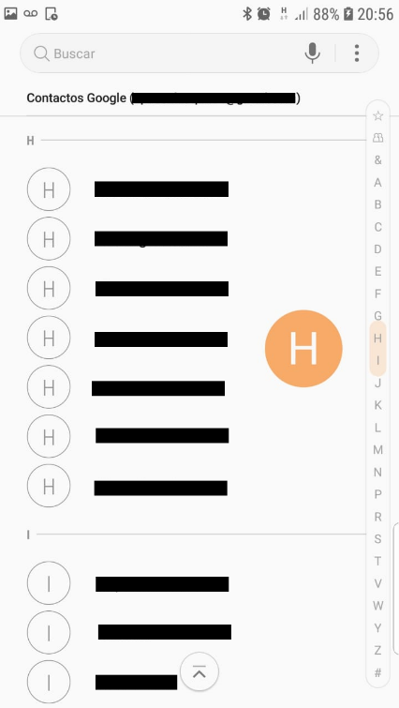

1. Incorporate a feedback when a searched city is not present in the list.
2. Incorporate a feedback when there is not internet connection.
3. Define some KPA (Key performance indicator), for example max time to wait for the filtered list.
4. Automate the app using other frameworks that allow us interact with the map.